**Project Design Phase**

**Solution Architecture**

|  |  |
| --- | --- |
| Date | 27 June 2025 |
| Team ID | LTVIP2025TMID32189 |
| Project Name | EduTutor AI: Personalized Learning with Generative AI and LMS Integration |
| Maximum Marks | 4 Marks |

**Solution Architecture:**

Solution architecture is a complex process – with many sub-processes – that bridges the gap between business problems and technology solutions. Its goals are to:

**🎯 Purpose:**

**EduTutor AI aims to deliver a personalized learning experience using generative AI. Its architecture connects users with language models through a lightweight interface, enabling concept explanation, grammar tutoring, and quiz generation from topics or PDFs — all without requiring complex backend frameworks.**

**🧱 Architecture Overview**

**The architecture is composed of the following layers:**

* **User Interface Layer (Gradio)  
  A no-code, interactive interface built entirely with Gradio Blocks, enabling:**
  + **Login/Register functionality**
  + **Concept input**
  + **Language selection**
  + **PDF upload for test generation**
  + **AI response display**
* **Logic & Processing Layer (Python)**
  + **Handles user input, session management, and routing logic**
  + **Uses PyPDF2 to extract and process PDF content**
  + **Stores user session data and quiz state using Python dictionaries (user_sessions)**
* **AI Model Layer (Hugging Face Transformers)**
  + **Integrates the IBM Granite 3.3-2B-Instruct model using Hugging Face pipeline**
  + **Performs text generation for:**
    - **Concept explanations**
    - **Grammar lessons (Hindi/English)**
    - **Quiz/test creation from topics or PDF inputs**

**Example - Solution Architecture Diagram:**

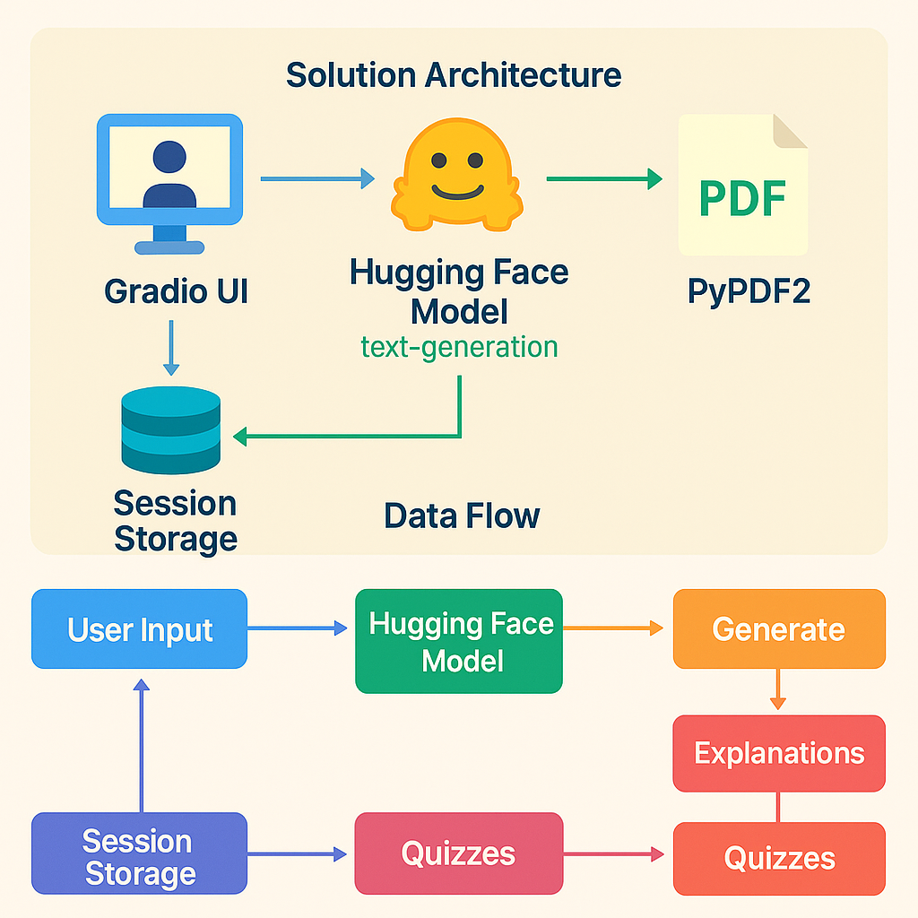

*Figure 1: Architecture and data flow of the EduTutor AI: Personalized Learning with Generative AI and LMS Integration.*